**Programming Fundamentals**

**Lab Report**

**Lab 11**



|  |  |
| --- | --- |
| Group Members Name & Reg #: | **Muhammad Haris Irfan**  **(FA18-BCE-090)** |
|  |  |
| Class | Programming Fundamentals CSC103 (**BCE-2B**) |
| Instructor’s Name | Dilshad Sabir |

**In Lab Tasks**

**Question no: 1**

Write a C Program that does the following:

1. Declares a C-String called ‘**m1**’ and initializes it with text “Programming is great fun!”.

2. Uses C-function puts() to print this string.

3. Asks the user to enter a String named ‘**m2**’ (**Hint**: Use gets() function for this.)

4. Concatenates the two strings and stores the result in ‘**m3**’.

For example, if the user enters **m2** as “Not Really!”, **m3** should be “Programming is great

fun! Not really!”

5. Inserts the user entered array (**m2**) into **m1** after “Programming is ...”

**Solution:**

The Code for the following code is attached below,

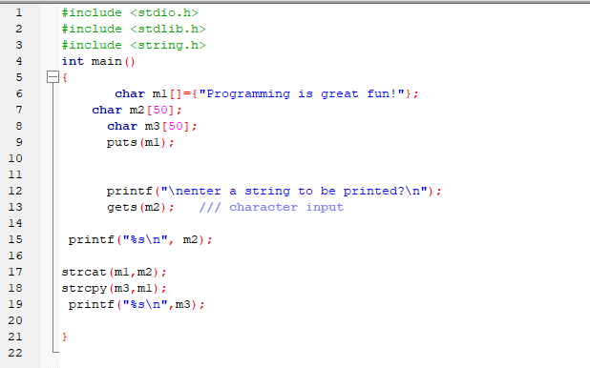

The Result of the following code is attached below:

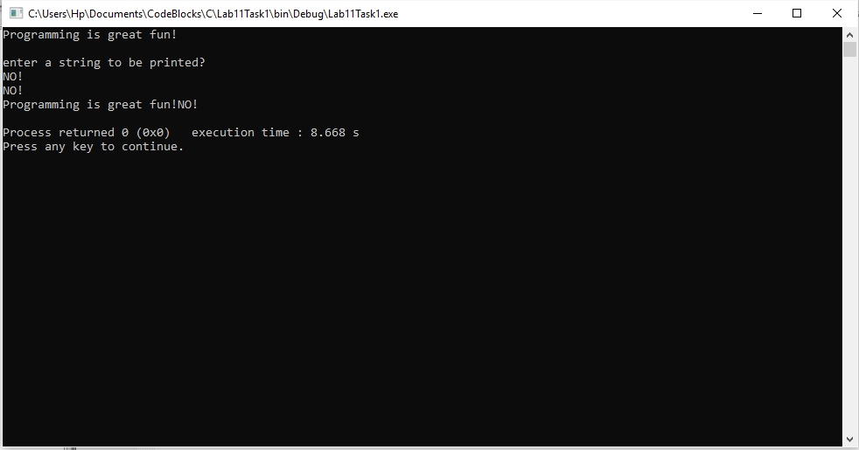

-------------------------------

**Question no: 2(A)**

Write a program that converts a string like "124" to an integer 124.

Solution

The code is shown below for the given program,

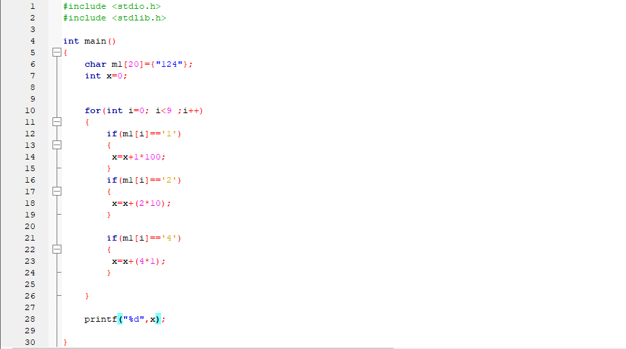

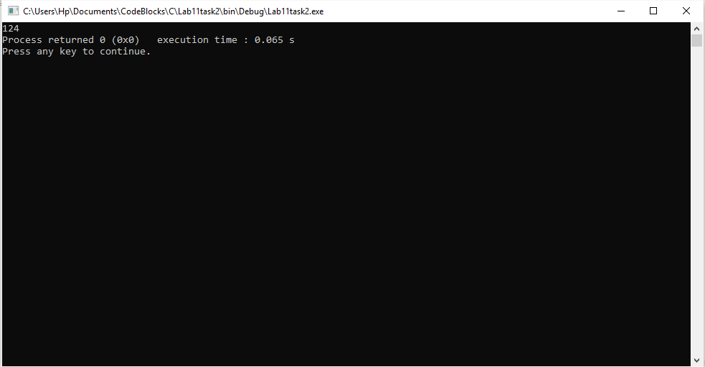The Result of the following code is attached below:

-------------------------------

**Question no: 2(B)**

Write a program that replaces two or more consecutive blanks in a string by a single blank.

For example, if the input is

“Grim return to the planet of apes!!”

the output should be

“Grim return to the planet of apes!!”

Solution

The code is shown below for the given program**,**

~~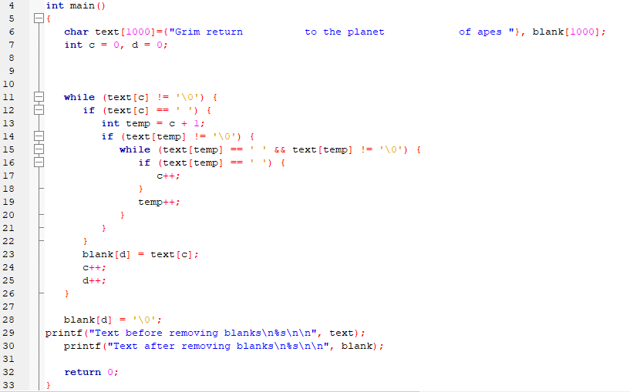~~

The Result of the following code is attached below:

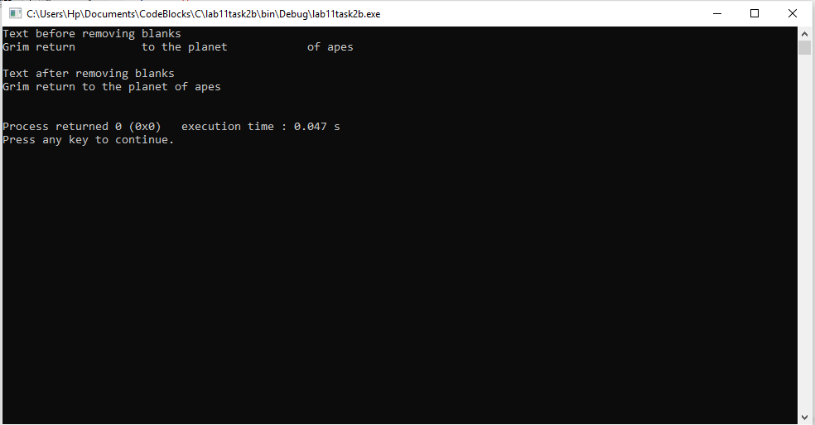

------------------------------

THE END

*there was no post lab for this lab.